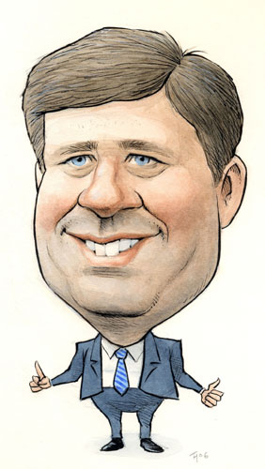

Here are some great political cartoon sites:

[**http://www.cagle.com/**](http://www.cagle.com/)[**http://www.mackaycartoons.net/**](http://www.mackaycartoons.net/)[**http://www.mapleleafweb.com/political-cartoons**](http://www.mapleleafweb.com/political-cartoons)

Political cartoonists use all or some of the following techniques when creating cartoons:

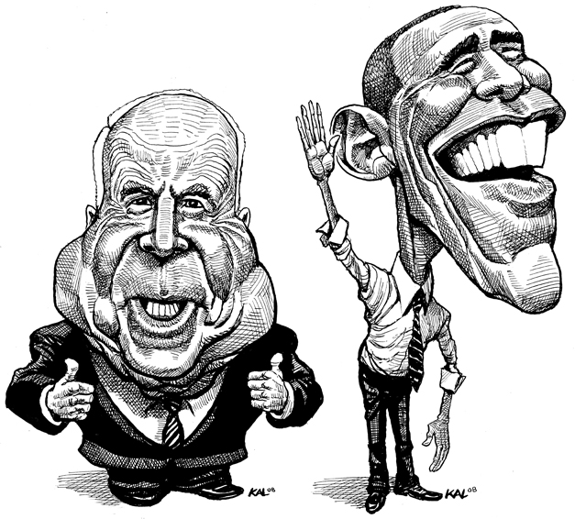

**S-Symbolism**

**S-Size**

**T-Text**

**I - Irony**

**C-Colour**

**A-Analogy**

**Symbolism**

Symbolism is perhaps the most common tool used by editorial cartoonists. Symbols liberate cartoonists by allowing them share concepts and ideas in visual form. A symbol, or object, can be used as a simple representation of a larger concept or idea For example, a cartoonist might use the image of a beaver to symbolize Canada or a Canadian citizen.

**Size**

Cartoonists will often exaggerate features within a cartoon to underscore its relative importance to the message being conveyed. Objects can be drawn excessively large to communicate importance or prominence, whereas smaller objects might be construed as less important. Cartoonists caricature famous people by exaggerating their physical features, which allows viewers to make easy connections to the subjects being used.

**Text**

Even though cartoons are visual, reading the text is crucial to understanding. Cartoonists will often label objects or people within a cartoon to make it clear what they stand for.

**Irony**

A cartoonist uses irony when they express something different from and often opposite to their literal meaning. Irony is an expression or utterance marked by a deliberate contrast between apparent and intended meaning.

Cartoonists will often use irony to express their opinion on a topic or issue**.** An example of irony could be found in a cartoon that shows a politician who introduces a bill on ethics and then is caught doing something unethical.

**Colour**

Although most political cartoons are black and white, the use of dark and light can add to the tone and the meaning of the cartoon. A dark cartoon can evoke a more serious or somber tone, whereas a brighter cartoon can reveal less serious context.

**Analogy**

The use of analogy is a more complex version of symbolism. An analogy is a comparison between two unlike things that share some characteristics. The cartoonist can use analogy to compare a complex issue or concept with a more familiar one. Usually the analogy is drawn with something that would be well known to most people, but if the necessary context is not understood then a cartoon using analogy can be difficult to understand.

Find a minimum of **three cartoons** that use each of the techniques described on the previous page. Each cartoon may not use all of the techniques, but all of the techniques should be found within the three cartoons.

You need to interpret each cartoon and write a summary (see exemplar below) that references the ***SSTICA*** method.

[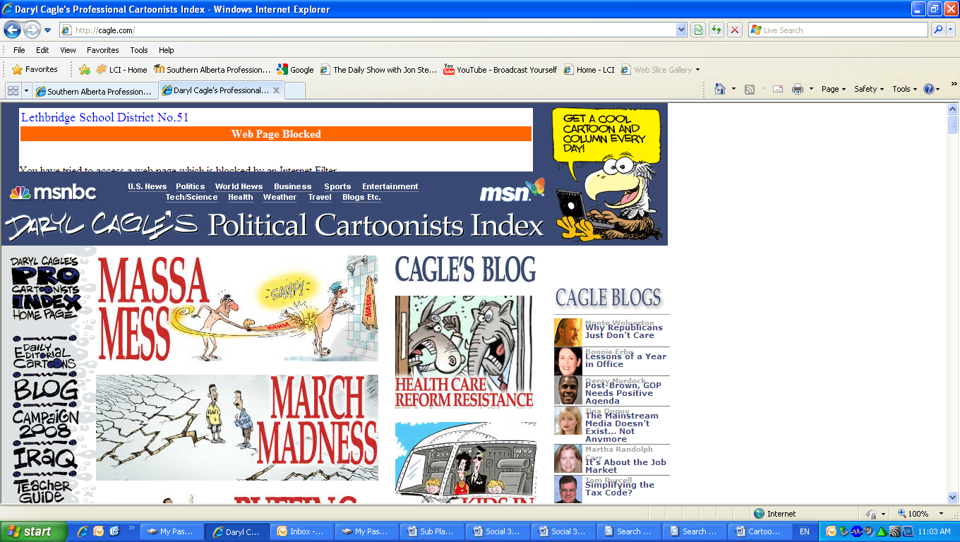](http://cagle.com/)

***Here is an example of a summary:***

*[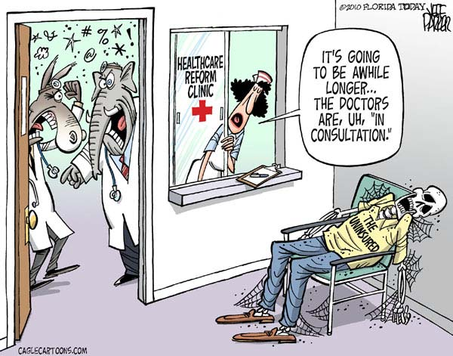](http://cagle.com/caglecards/main.asp?image=/news/ReformResistance/images/parker.jpg)This cartoon is by* ***Jeff Parker,*** *from**Florida Today, March 16, 2010. The cartoon explores the current issue surrounding healthcare reform in the United States. The cartoon uses the well-known image of a doctor’s office to connect to people’s personal experience – most people have been in the situation. There are numerous symbols being used in the cartoon. The red cross on the clinic window is a commonly recognized symbol of healthcare, most notably the international ‘Red Cross’ organization. The two doctors, clearly disagreeing over something, are symbolized by the characters over their heads that indicate they are likely swearing at each other. The doctors are portrayed as a donkey and an elephant, the most common symbols of the two main political parties in the United States (the Democrats – donkey and the Republicans – elephants). The Democrats are pushing for changes to an American healthcare system built upon key principles of liberalism such as self-interest, completion and economic freedom. Democrats would say that the large private for-profit insurance companies who control the system, and who advocate these principles, have been corrupted by greed and put profit. They are calling for reforms that would introduce strong government controls to regulate the industry in the name of establishing more economic equality and collective interest for American citizens. The corpse in the cartoon symbolizes the millions of American citizens who are left without, or who are purposefully excluded from, healthcare coverage. Republicans, with individualist principles at their core, are against government regulation and any policies that counter the aforementioned principles of liberalism. Republicans believe that a free market of insurance providers should be left alone to meet the needs of Americans and that individuals should find their own healthcare needs. The cartoonist perspective appears to be looking past the ideological differences of the warring political parties and is more sympathetic to the perspective of Americans suffering within the healthcare system. The cartoon comments on the fact reality that as the parties fight over politics, people in the United States are suffering and some are dying. There is irony in the fact that there is a corpse (symbolizing the uninsured people in the United States) in a health care facility waiting room.*