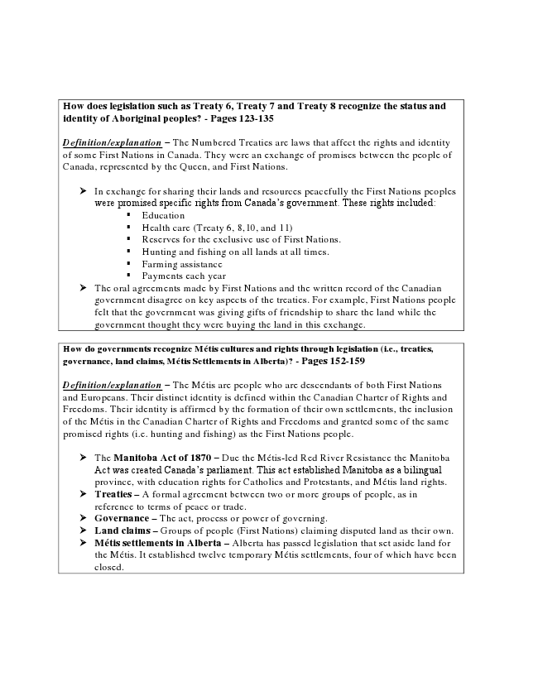

How does legislation such as Treaty 6, Treaty 7 and Treaty 8 recognize the status and identity of Aboriginal peoples? - Pages 123-135
Definition/explanation – The Numbered Treaties are laws that affect the rights and identity of some First Nations in Canada. They were an exchange of promises between the people of Canada, represented by the Queen, and First Nations.
In exchange for sharing their lands and resources peacefully the First Nations peoples were promised specific rights from Canada’s government.
These rights included:
▪ Education
▪ Health care (Treaty 6, 8,10, and 11)
▪ Reserves for the exclusive use of First Nations.
▪ Hunting and fishing on all lands at all times.
▪ Farming assistance
▪ Payments each year
The oral agreements made by First Nations and the written records of the Canadian government disagree on key aspects of the treaties. For example, First Nations people felt that the government was giving gifts of friendship to share the land while the government thought they were buying the land in this exchange.
How do governments recognize Métis cultures and rights through legislation (i.e., treaties, governance, land claims, Métis Settlements in Alberta)? - Pages 152-159
Definition/explanation – The Métis are people who are descendants of both First Nations and Europeans. Their distinct identity is defined within the Canadian Charter of Rights and Freedoms. Their identity is affirmed by the formation of their own settlements, the inclusion of the Métis in the Canadian Charter of Rights and Freedoms and granted some of the same promised rights (i.e. hunting and fishing) as the First Nations people.
- The Manitoba Act of 1870 – Due the Métis-led Red River Resistance the Manitoba Act was created Canada’s parliament. This act established Manitoba as a bilingual province, with education rights for Catholics and Protestants, and Métis land rights.
- Treaties – A formal agreement between two or more groups of people, as in reference to terms of peace or trade.
- Governance – The act, process or power of governing.
- Land claims – Groups of people (First Nations) claiming disputed land as their own.
- Métis settlements in Alberta – Alberta has passed legislation that set aside land for the Métis. It established twelve temporary Métis settlements, four of which have been closed.

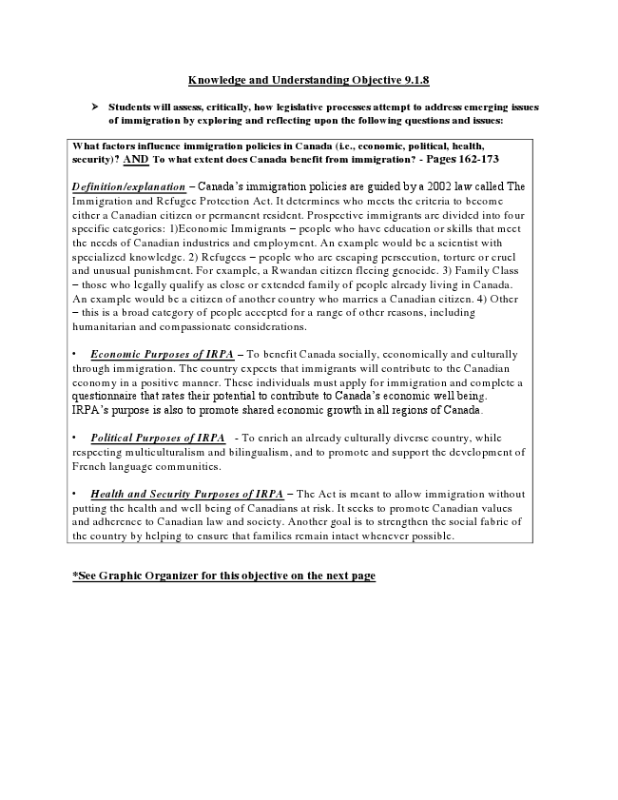

Knowledge and Understanding Objective 9.1.8
Students will assess, critically, how legislative processes attempt to address emerging issues of immigration by exploring and reflecting upon the following questions and issues:
What factors influence immigration policies in Canada (i.e., economic, political, health, security)? AND To what extent does Canada benefit from immigration? - Pages 162-173
Definition/explanation – Canada’s immigration policies are guided by a 2002 law called The Immigration and Refugee Protection Act. It determines who meets the criteria to become either a Canadian citizen or permanent resident. Prospective immigrants are divided into four specific categories:
1)Economic Immigrants – people who have education or skills that meet the needs of Canadian industries and employment. An example would be a scientist with specialized knowledge.
2) Refugees – people who are escaping persecution, torture or cruel and unusual punishment. For example, a Rwandan citizen fleeing genocide.
3) Family Class – those who legally qualify as close or extended family of people already living in Canada. An example would be a citizen of another country who marries a Canadian citizen.
4) Other – this is a broad category of people accepted for a range of other reasons, including humanitarian and compassionate considerations.
• Economic Purposes of IRPA – To benefit Canada socially, economically and culturally through immigration. The country expects that immigrants will contribute to the Canadian economy in a positive manner. These individuals must apply for immigration and complete a questionnaire that rates their potential to contribute to Canada’s economic well being. IRPA’s purpose is also to promote shared economic growth in all regions of Canada.
• Political Purposes of IRPA - To enrich an already culturally diverse country, while respecting multiculturalism and bilingualism, and to promote and support the development of French language communities.
• Health and Security Purposes of IRPA – The Act is meant to allow immigration without putting the health and well being of Canadians at risk. It seeks to promote Canadian values and adherence to Canadian law and society. Another goal is to strengthen the social fabric of the country by helping to ensure that families remain intact whenever possible.
*See Graphic Organizer for this objective on the next page

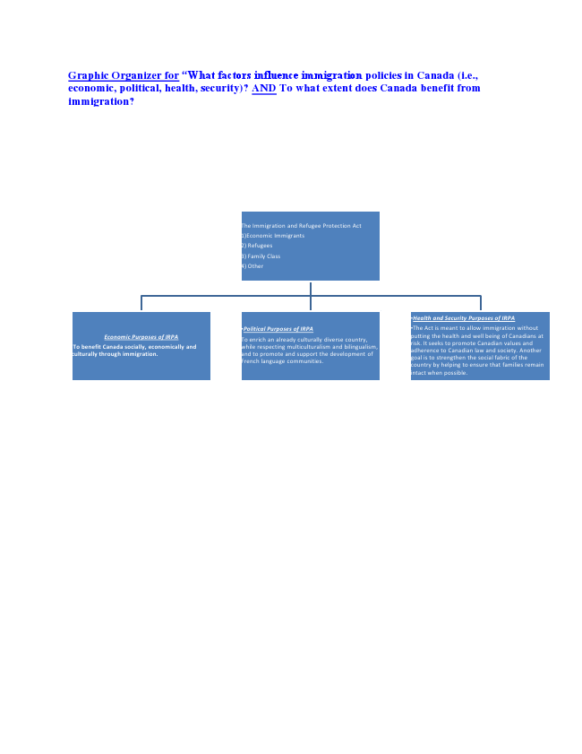

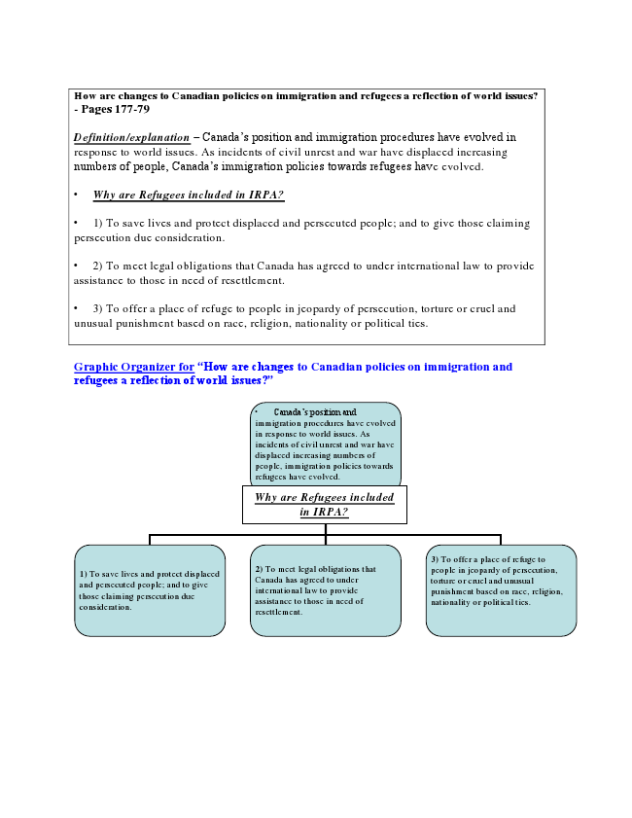

How are changes to Canadian policies on immigration and refugees a reflection of world issues? - Pages 177-79
Definition/explanation – Canada’s position and immigration procedures have evolved in response to world issues. As incidents of civil unrest and war have displaced increasing numbers of people, Canada’s immigration policies towards refugees have evolved.
• Why are Refugees included in IRPA?
• 1) To save lives and protect displaced and persecuted people; and to give those claiming persecution due consideration.
• 2) To meet legal obligations that Canada has agreed to under international law to provide assistance to those in need of resettlement.
• 3) To offer a place of refuge to people in jeopardy of persecution, torture or cruel and unusual punishment based on race, religion, nationality or political ties.

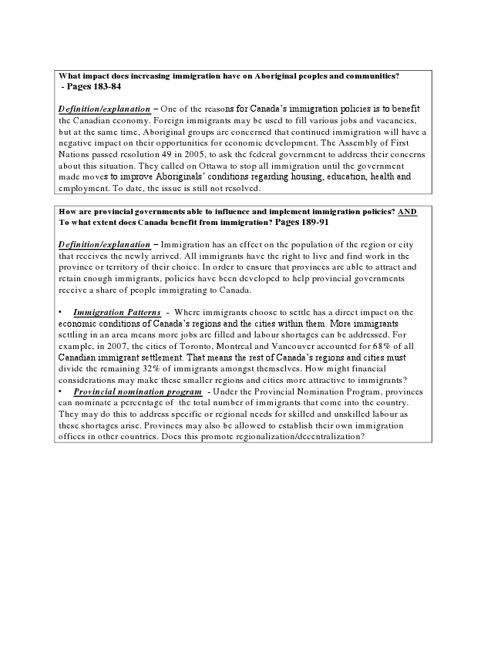

What impact does increasing immigration have on Aboriginal peoples and communities?
- Pages 183-84
Definition/explanation – One of the reasons for Canada’s immigration policies is to benefit the Canadian economy. Foreign immigrants may be used to fill various jobs and vacancies, but at the same time, Aboriginal groups are concerned that continued immigration will have a negative impact on their opportunities for economic development. The Assembly of First Nations passed resolution 49 in 2005, to ask the federal government to address their concerns about this situation. They called on Ottawa to stop all immigration until the government made moves to improve Aboriginals’ conditions regarding housing, education, health and employment. To date, the issue is still not resolved.
How are provincial governments able to influence and implement immigration policies? AND To what extent does Canada benefit from immigration? Pages 189-91
Definition/explanation – Immigration has an effect on the population of the region or city that receives the newly arrived. All immigrants have the right to live and find work in the province or territory of their choice. In order to ensure that provinces are able to attract and retain enough immigrants, policies have been developed to help provincial governments receive a share of people immigrating to Canada.
• Immigration Patterns - Where immigrants choose to settle has a direct impact on the economic conditions of Canada’s regions and the cities within them. More immigrants settling in an area means more jobs are filled and labour shortages can be addressed. For example, in 2007, the cities of Toronto, Montreal and Vancouver accounted for 68% of all Canadian immigrant settlement. That means the rest of Canada’s regions and cities must divide the remaining 32% of immigrants amongst themselves. How might financial considerations make these smaller regions and cities more attractive to immigrants?
• Provincial nomination program - Under the Provincial Nomination Program, provinces can nominate a percentage of the total number of immigrants that come into the country. They may do this to address specific or regional needs for skilled and unskilled labour as these shortages arise. Provinces may also be allowed to establish their own immigration offices in other countries. Does this promote regionalization/decentralization?

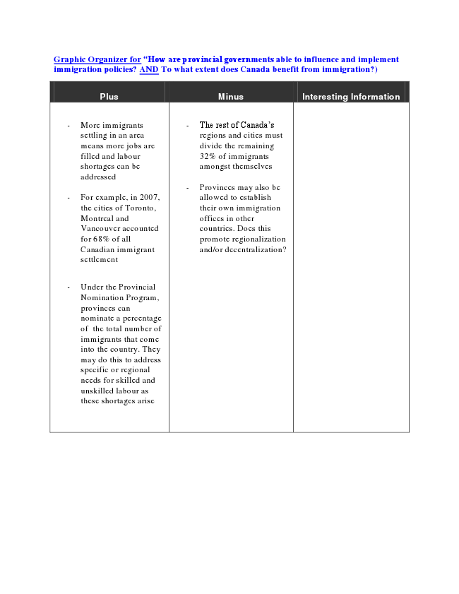

“How are provincial governments able to influence and implement immigration policies? AND To what extent does Canada benefit from immigration?)
Plus Minus Interesting Information
- More immigrants settling in an area means more jobs are filled and labour shortages can be addressed
- For example, in 2007, the cities of Toronto, Montreal and Vancouver accounted for 68% of all Canadian immigrant settlement
- Under the Provincial Nomination Program, provinces can nominate a percentage of the total number of immigrants that come into the country. They may do this to address specific or regional needs for skilled and unskilled labour as these shortages arise
- The rest of Canada’s regions and cities must divide the remaining 32% of immigrants amongst themselves
- Provinces may also be allowed to establish their own immigration offices in other countries. Does this promote regionalization and/or decentralization?

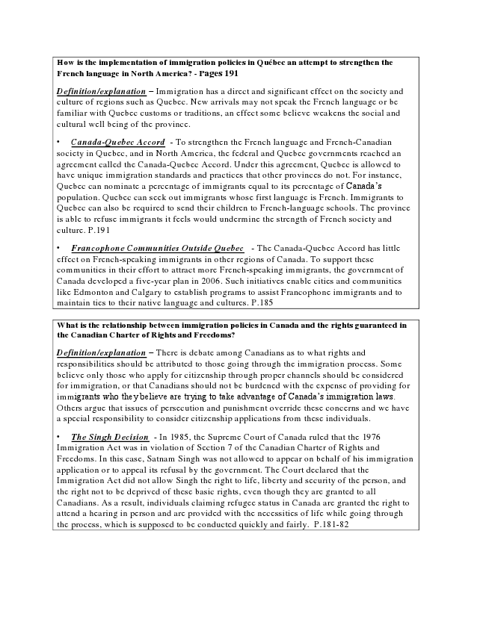

How is the implementation of immigration policies in Québec an attempt to strengthen the French language in North America? - Pages 191
Definition/explanation – Immigration has a direct and significant effect on the society and culture of regions such as Quebec. New arrivals may not speak the French language or be familiar with Quebec customs or traditions; an effect some believe weakens the social and cultural well being of the province.
• Canada-Quebec Accord - To strengthen the French language and French-Canadian society in Quebec, and in North America, the federal and Quebec governments reached an agreement called the Canada-Quebec Accord. Under this agreement, Quebec is allowed to have unique immigration standards and practices that other provinces do not. For instance, Quebec can nominate a percentage of immigrants equal to its percentage of Canada’s population. Quebec can seek out immigrants whose first language is French. Immigrants to Quebec can also be required to send their children to French-language schools. The province is able to refuse immigrants it feels would undermine the strength of French society and culture. P.191
• Francophone Communities Outside Quebec - The Canada-Quebec Accord has little effect on French-speaking immigrants in other regions of Canada. To support these communities in their effort to attract more French-speaking immigrants, the government of Canada developed a five-year plan in 2006. Such initiatives enable cities and communities like Edmonton and Calgary to establish programs to assist Francophone immigrants and to maintain ties to their native language and cultures. P.185
What is the relationship between immigration policies in Canada and the rights guaranteed in the Canadian Charter of Rights and Freedoms?
Definition/explanation – There is debate among Canadians as to what rights and responsibilities should be attributed to those going through the immigration process. Some believe only those who apply for citizenship through proper channels should be considered for immigration, or that Canadians should not be burdened with the expense of providing for immigrants who they believe are trying to take advantage of Canada’s immigration laws. Others argue that issues of persecution and punishment override these concerns and we have a special responsibility to consider citizenship applications from these individuals.
• The Singh Decision - In 1985, the Supreme Court of Canada ruled that the 1976 Immigration Act was in violation of Section 7 of the Canadian Charter of Rights and Freedoms. In this case, Satnam Singh was not allowed to appear on behalf of his immigration application or to appeal its refusal by the government. The Court declared that the Immigration Act did not allow Singh the right to life, liberty and security of the person, and the right not to be deprived of these basic rights, even though they are granted to all Canadians. As a result, individuals claiming refugee status in Canada are granted the right to attend a hearing in person and are provided with the necessities of life while going through the process, which is supposed to be conducted quickly and fairly. P.181-82

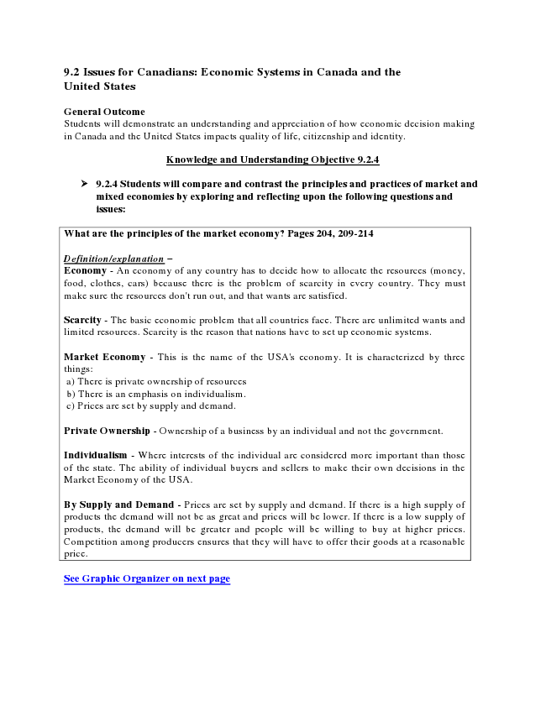
9.2 Issues for Canadians: Economic Systems in Canada and the United States
General Outcome Students will demonstrate an understanding and appreciation of how economic decision making in Canada and the United States impacts quality of life, citizenship and identity.
Knowledge and Understanding Objective 9.2.4
9.2.4 Students will compare and contrast the principles and practices of market and mixed economies by exploring and reflecting upon the following questions and issues:
What are the principles of the market economy? Pages 204, 209-214
Definition/explanation –
Economy - An economy of any country has to decide how to allocate the resources (money, food, clothes, cars) because there is the problem of scarcity in every country. They must make sure the resources don't run out, and that wants are satisfied.
Scarcity - The basic economic problem that all countries face. There are unlimited wants and limited resources. Scarcity is the reason that nations have to set up economic systems.
Market Economy - This is the name of the USA's economy. It is characterized by three things: a) There is private ownership of resources b) There is an emphasis on individualism. c) Prices are set by supply and demand.
Private Ownership - Ownership of a business by an individual and not the government.
Individualism - Where interests of the individual are considered more important than those of the state. The ability of individual buyers and sellers to make their own decisions in the Market Economy of the USA.
By Supply and Demand - Prices are set by supply and demand. If there is a high supply of products the demand will not be as great and prices will be lower. If there is a low supply of products, the demand will be greater and people will be willing to buy at higher prices. Competition among producers ensures that they will have to offer their goods at a reasonable price.
See Graphic Organizer on next page

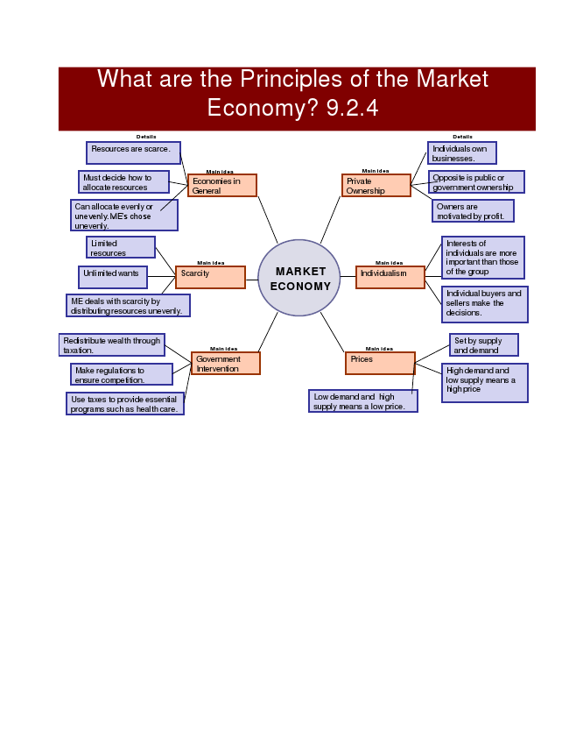

Market Economy
Economies in General
Resources are scarce.
Must decide how to allocate resources
Can allocate evenly or unevenly. Market Economie’s chose unevenly.

Scarcity
Limited resources
Unlimited wants
Market Economies deal with scarcity by distributing resources unevenly.

Government Intervention
Redistribute wealth through taxation.
Make regulations to ensure competition.
Use taxes to provide essential programs such as health care.

Private Ownership
Individuals own businesses.
Opposite is public or government ownership
Owners are motivated by profit.

Individualism
Interests of individuals are more important than those of the group
Individual buyers and sellers make the decisions.

Prices
Set by supply and demand
Low demand and high supply means a low price.
High demand and low supply means a high price.
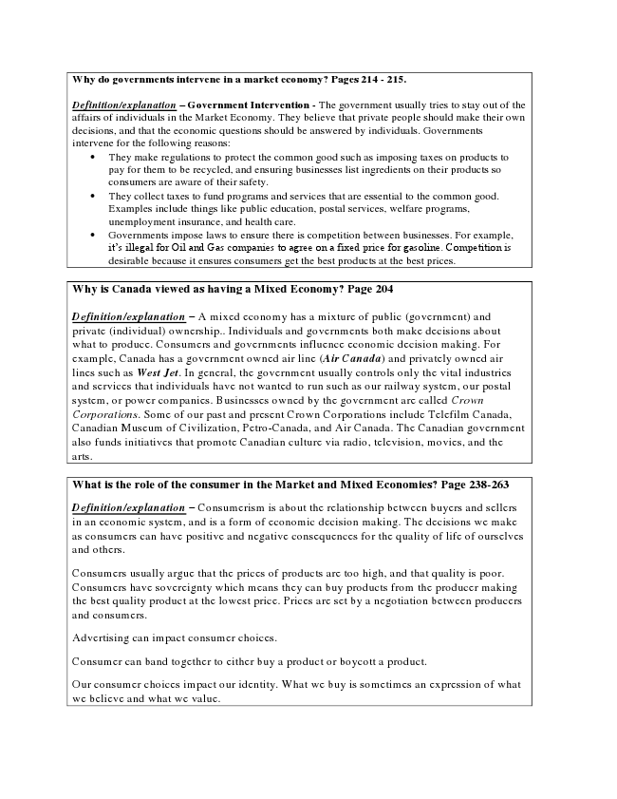

Why do governments intervene in a market economy? Pages 214 - 215.
Definition/explanation – Government Intervention - The government usually tries to stay out of the affairs of individuals in the Market Economy. They believe that private people should make their own decisions, and that the economic questions should be answered by individuals. Governments intervene for the following reasons:
• They make regulations to protect the common good such as imposing taxes on products to pay for them to be recycled, and ensuring businesses list ingredients on their products so consumers are aware of their safety.
• They collect taxes to fund programs and services that are essential to the common good. Examples include things like public education, postal services, welfare programs, unemployment insurance, and health care.
• Governments impose laws to ensure there is competition between businesses. For example, it’s illegal for Oil and Gas companies to agree on a fixed price for gasoline. Competition is desirable because it ensures consumers get the best products at the best prices.
Why is Canada viewed as having a Mixed Economy? Page 204
Definition/explanation – A mixed economy has a mixture of public (government) and private (individual) ownership. Individuals and governments both make decisions about what to produce. Consumers and governments influence economic decision-making. For example, Canada has a government owned airline (Air Canada) and privately owned airlines such as West Jet. In general, the government usually controls only the vital industries and services that individuals have not wanted to run such as our railway system, our postal system, or power companies. Businesses owned by the government are called Crown Corporations. Some of our past and present Crown Corporations include Telefilm Canada, Canadian Museum of Civilization, Petro-Canada, and Air Canada. The Canadian government also funds initiatives that promote Canadian culture via radio, television, movies, and the arts.
What is the role of the consumer in the Market and Mixed Economies? Page 238-263
Definition/explanation – Consumerism is about the relationship between buyers and sellers in an economic system, and is a form of economic decision-making. The decisions we make as consumers can have positive and negative consequences for the quality of life of others and ourselves.
Consumers usually argue that the prices of products are too high, and that quality is poor. Consumers have sovereignty, which means they can buy products from the producer making the best quality product at the lowest price. Prices are set by a negotiation between producers and consumers.
Advertising can impact consumer choices.
Consumer can band together to either buy a product or boycott a product.
Our consumer choices impact our identity. What we buy is sometimes an expression of what we believe and what we value.

